Newborn Care Module Interviewer Instructions

Qs. NB1-NB8: NEWBORN CARE

There are some basic newborn care actions that are critical for child survival. Qs. NB1-NB2 ask about whether the newborn was wiped dry soon after birth and how long after birth the newborn was bathed for the first time.

Q. NB3 filters for whether a woman gave birth in a facility. Women who gave birth in a facility (Q. 430 = 21-36) will be marked [CODE 21 – 36] in NB3 and skip to Q. NB 7. Women who delivered at home (their own home or someone else’s), or were recorded as place of delivery with code 96 will be marked [Code 11, 12, or 96] in NB3, and proceed with NB4.

Qs. NB4-NB6 ask about what was used to cut the umbilical cord. Q. NB4 asks what instrument was used to cut it; Q. NB5 asks if the instrument was new (completely unused) or had ever been used before; and Q. NB6 asks whether the instrument was boiled before it was used to cut the cord.

Various substances may be applied to the stump of the umbilical cord once it has been cut. Qs. NB7-NB8 ask whether anything was applied and if so, what it was.

Qs. CH1-CH5: CHLORHEXIDINE

Chlorhexidine is an antiseptic that the WHO recommends be the sole substance applied to umbilical stumps. Some women may have seen chlorhexidine in use or been given chlorhexidine to apply at home. Sample instructions for its use are shown below. Qs. CH1 and CH2 filter for chlorhexidine use. Q. CH3 ascertains how long after the cord cutting chlorhexidine was applied, Q. CH4 asks for how many days after birth chlorhexidine was applied, and Q. CH5 asks how many times per day chlorhexidine was applied.

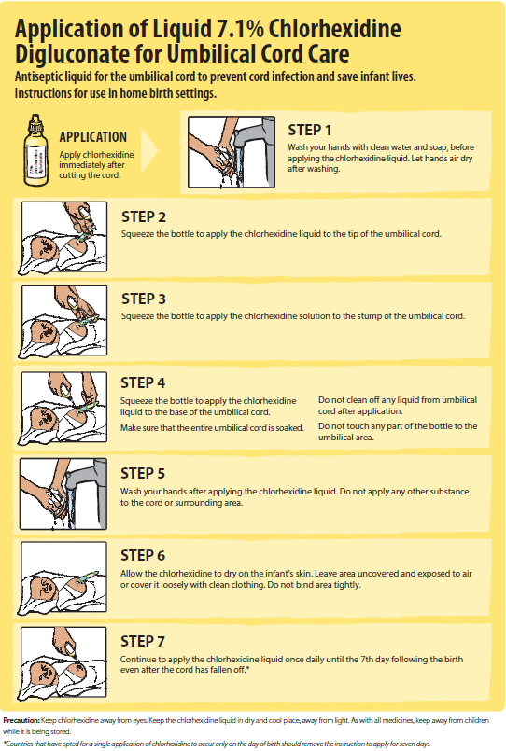

End of NB instructions.

